Step by Step Guide

install json-server

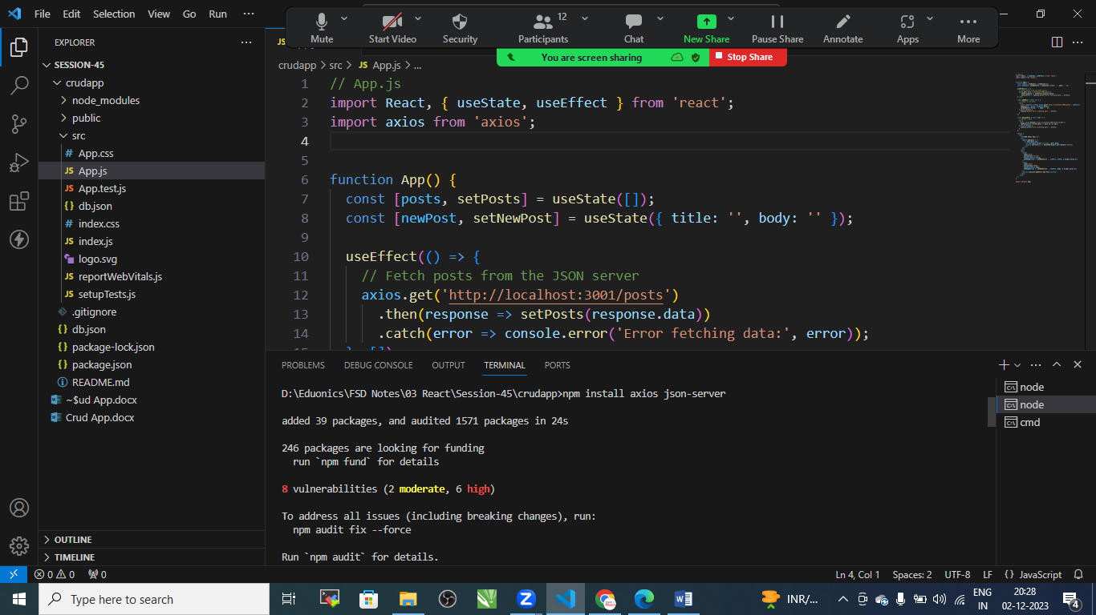

* npm install axios json-server

Step:2 Create Fake JSON Server

Create db.json file under src folder

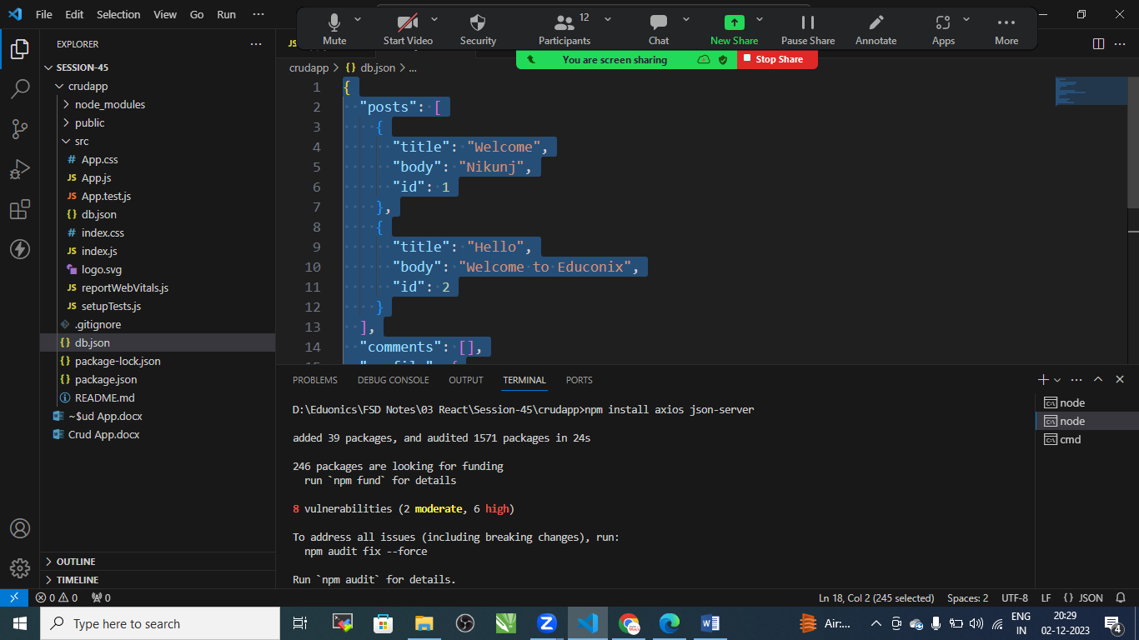

{

  "posts": [

    {

      "title": "Welcome",

      "body": "Nikunj",

      "id": 1

    },

  ]

}

Step:3 package.json

Add this to scripts:

"scripts": {

    "start": "react-scripts start",

    "build": "react-scripts build",

    "test": "react-scripts test",

    "eject": "react-scripts eject",

    "start":"json-server --watch db.json --port 3001",

    "start-reat":"react-scripts start"

  },

Step:4 Start json Server

* npm run start

step:5 app.js file

// App.js

import React, { useState, useEffect } from 'react';

import axios from 'axios';

function App() {

  const [posts, setPosts] = useState([]);

  const [newPost, setNewPost] = useState({ title: '', body: '' });

  useEffect(() => {

    // Fetch posts from the JSON server

    axios.get('http://localhost:3001/posts')

      .then(response => setPosts(response.data))

      .catch(error => console.error('Error fetching data:', error));

  }, []);

  const addPost = async () => {

    // Create a new post

    try {

      const response = await axios.post('http://localhost:3001/posts', newPost);

      setPosts([...posts, response.data]);

      setNewPost({ title: '', body: '' });

    } catch (error) {

      console.error('Error creating post:', error);

    }

  };

  const deletePost = async (id) => {

    // Delete a post

    try {

      await axios.delete(`http://localhost:3001/posts/${id}`);

      setPosts(posts.filter(post => post.id !== id));

    } catch (error) {

      console.error('Error deleting post:', error);

    }

  };

  return (

    <div>

      <h1>CRUD Admin App</h1>

      <ul>

        {posts.map(post => (

          <li key={post.id}>

            <strong>{post.title}</strong>: {post.body}

            <button onClick={() => deletePost(post.id)}>Delete</button>

          </li>

        ))}

      </ul>

      <div>

        <input

          type="text"

          placeholder="Title"

          value={newPost.title}

          onChange={(e) => setNewPost({ ...newPost, title: e.target.value })}

        />

        <input

          type="text"

          placeholder="Body"

          value={newPost.body}

          onChange={(e) => setNewPost({ ...newPost, body: e.target.value })}

        />

        <button onClick={addPost}>Add Post</button>

      </div>

    </div>

  );

}

export default App;

step:5 start the app: npm start